Math 4 Name__________________________________

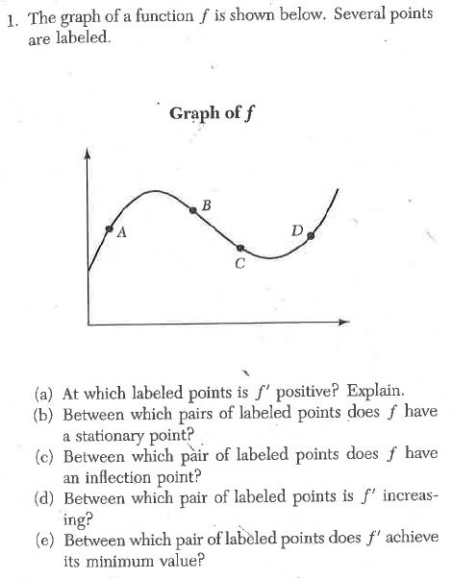**5-6 Practice** Date___________

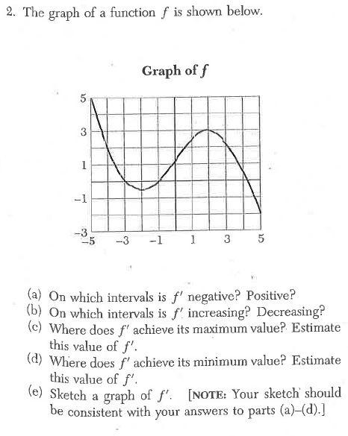

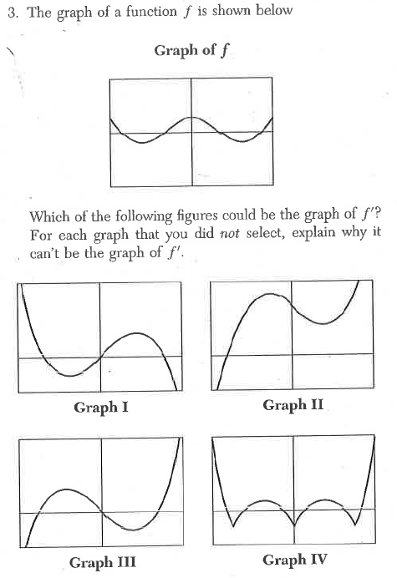

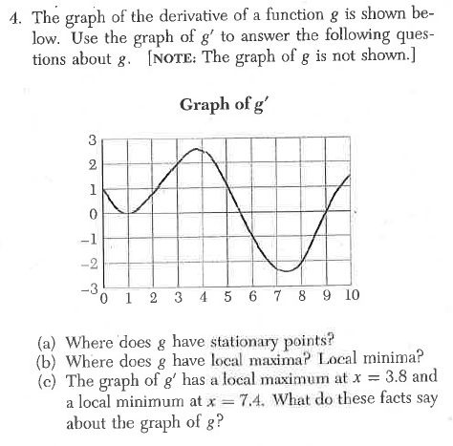

5?

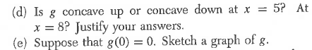

**In problems 5 and 6, be sure to explain why your choice is correct.**

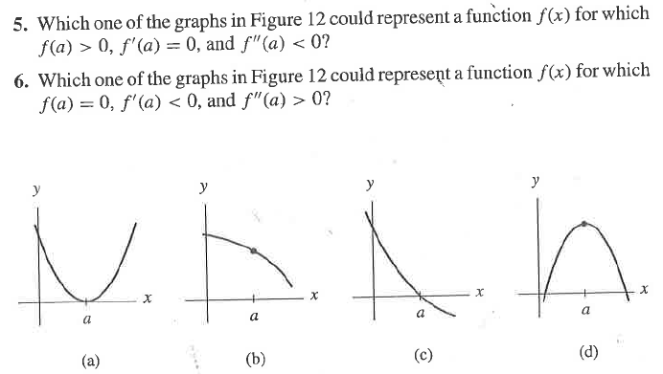

**For problems 7 and 8, sketch a possible graph of *f*(*x*) given the following characteristics.**

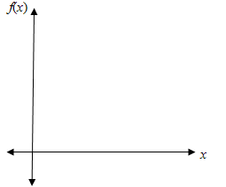

**7. 8.**

**9.**

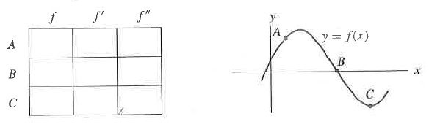

**10.** *Show all work for the following. NO CALCULATOR UNTIL PART e!*

a. Find . Determine the intervals on which *f*  is increasing & decreasing. *Hint: NLA!*

b. Use your *NLA* to determine the coordinates of the relative maximum and relative minimum.

c. Find . Determine the intervals on which *f*  is concave up & concave down. *Hint: NLA!*

d. Use your *NLA* to determine the coordinates of the point(s) of inflection.

e. Check your answers to parts a – d using your calculator. (You do not have to sketch the graph.)